Mallu Sravana Sandhya Assessment-10 14/12/2023

DATATYPE:it specifies the data to which it belongs to

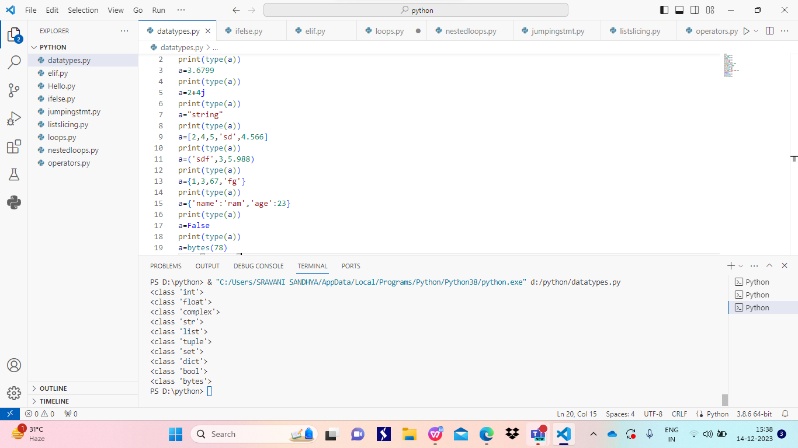

OPERATORS:

Arithmetic operators- perform arithmetic functions

Logical operators- returns true or false

Relational operators- compare the data and returns boolean value

Bitwise operator- it performs bitwise operations in terms of 0s and 1s

Identity operator- it returns true if given data is identical otherwise false

Membership operator- it returns boolean value by by checking given data is present in the list

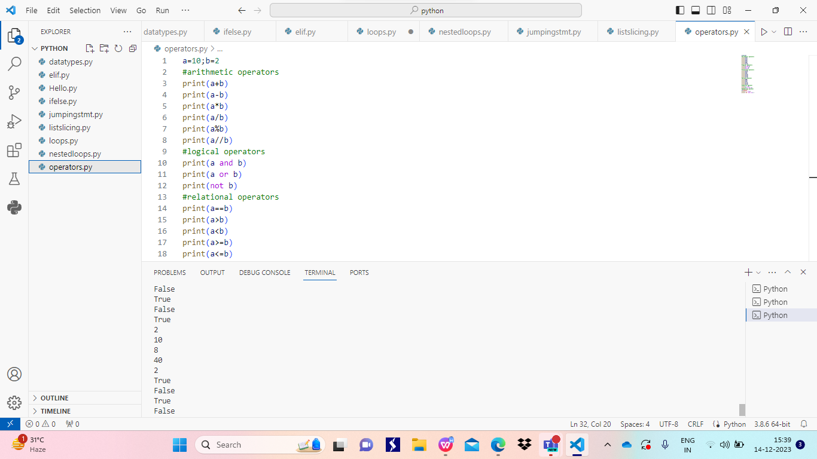

NESTEDLOOPS:loops present inside another loop

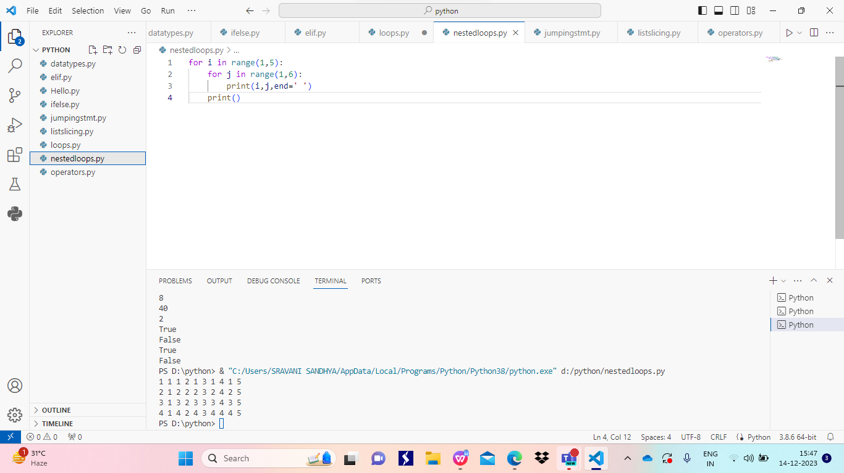

JUMPING STATEMENTS

Break:-when flow of execution meets break it will come out of the loop

Continue:-it skips the present iteration and continues the loop

Pass:-it does nothing in code used only for syntactic purpose

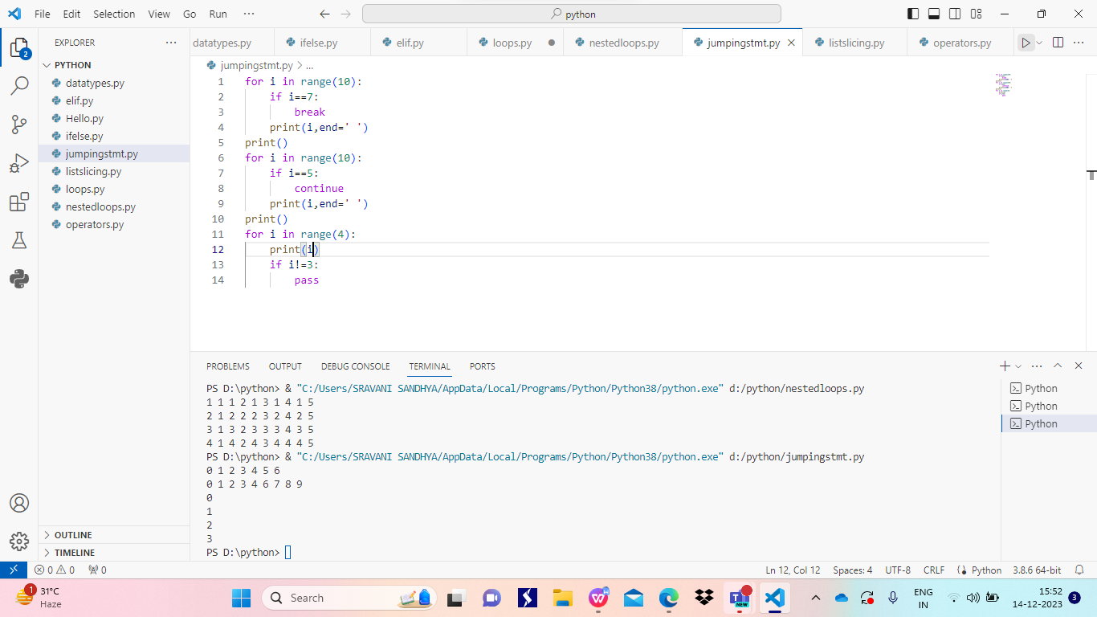

Slicing:

This will help us to get a part of data from list,tuple,dictonary,set,….

Syntax:

Setvaribale[startindex:stopindex:step]

